Travel agency "TRAVELLINO" was founded in 2002. It is our great pleasure to have returning satisfied customers who carry on thinking and seeing through new and exciting travels with us.
"TRAVELLINO" is organizing tourist trips to following European cities: Budapest, Vienna, Prague, Istanbul, Toscana, Rome, Trebinje, Sarajevo, Krakow, Venice, Paris, ..., primary and high school excursions, summer and winter holidays... With us, you can travel to unforgettable cruises or an exotic faraway destination. We're taking you to one-day field trips to some of the most intriguing cities of the countries in the region or one of many Hungarians spa resorts so that you can enjoy a relaxing experience and at least for a short while put those daily worries aside. Get to know Serbia through one-day field trips: Dundjerski family castles, Subotica, Palic, live music and meals in Vojvodina's salas, monasteries (Furska Gora and other localities), one of many caves (Resava, Rajko's, Risovaca, ...), enjoy sizzling lamb roasts overlooking beautiful waterfalls, East Serbia tours and many other memorable experiences you will cherish for a long time to come.
If you are looking for a local partner – incoming tour operator for Serbia and Balkan/Southeast Europe, with a lot of experience in different thematic tours and with different types of audiences, you are at the right place.

Belgrade is the capital city of Serbia and has a population of around 1.7 million. It is one of the oldest cities in Europe. The city lies on two international waterways, at the confluence of the Sava and Danube rivers. It has many well-known attractions, such as Belgrade Fortress, the oldest cultural and historical landmark in Belgrade, Skadarlija, Zemun with Gardos, bohemian quarters; the Residence of Princess Ljubica; Captain Misa’s Building; the Old Palace and New Palace; the Serbian National Assembly building, the Cathedral of Saint Sava, which is the biggest orthodox church in Europe.
It’s a “must-see” destination! A city that never sleeps, with urban nightlife during the whole week, city break destination, a cultural center with numerous local and international theatres, film, music events (FEST, BITEF, BEMUS, BELEF), the centre of MICE tourism and a shopping destination.
We can organize different sightseeing tours: walking tour, by bus or by ship. Tour usually starts by visiting Belgrade Fortress with a magnificent view on the confluence of the Sava into the Danube River and Zemun town. Tour continues to Kalemegdan Park, National Theatre, National Museum, Belgrade University, the main pedestrian zone of Knez Mihailova Street, City Hall, State Parliament and more. According to the preference of a group, the route can be modified. We can provide different speaking tour guides.

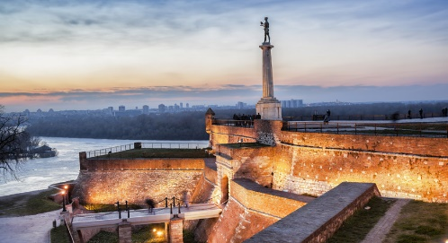

Novi Sad is the second-largest city in Serbia, the administrative seat of Vojvodina and the administrative center of the South Backa District. Novi Sad is the economic center of Vojvodina, the most fertile agricultural region in Serbia.
Today, Novi Sad is the second cultural center in Serbia (besides Belgrade) and city officials try to make the city more attractive to numerous cultural events and music concerts. Since 2000, Novi Sad is home to the EXIT festival, the biggest music summer festival in Serbia and the region; and also the only festival of alternative and new theatre in Serbia. Every year, at the beginning of July, during the annual EXIT music festival, the city is full of young people from all over Europe.
The guided tour includes visiting the old heart of the city, Petrovaradin fortress, City Hall, parish church called the Name of Mary Church, the Synagogue, the Ballet School and the Jewish Community building, Bishop’s Residence and other city’s highlights. Sremski Karlovci is a town and municipality in Serbia, in the autonomous province of Vojvodina, situated on the bank of the river Danube, 8 km from Novi Sad. The town has traditionally been known as the seat of the Serbian Orthodox Church in the Habsburg Monarchy, as well as the political and cultural capital of Serbian Vojvodina after the May Assembly and during the Revolution in 1848. According to a legend, whoever drinks water from the Four Lions Fountain, built in the year 1799, will return to Sremski Karlovci to marry. Also, Serbia’s oldest gymnasium is located here. Sremski Karlovci produces excellent wine. Its rustic cellars draw more and more visitors each year. The area’s vineyards add to its quaint character and beautiful scenery. This tour can include wine tasting.

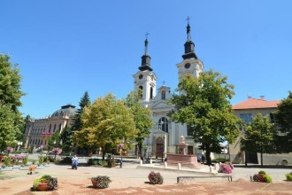

Niš is 238km away from Belgrade, accessible via highway. Sometime before the birth of Christ, the Romans conquered this town and named it Naissus. It is the birthplace of the Emperor, Constantine the Great.
Cele kula (Skull Tower) is easily one of Nis’s most important sights. Located 2km from the city center, it was erected following the gory battle between the Serbian army and the Turks on Cegar. After the battle, the Turkish Commander Hushid-pasha ordered his soldiers to skin a head of every fallen Serbian soldier, fill it with hay, send it to the Sultan of Stambol (Istanbul) and stack the skulls into a tower which would serve as a permanent warning to the Serbian people. Of the total 852 skulls that were used to build the tower, 58 are preserved today.
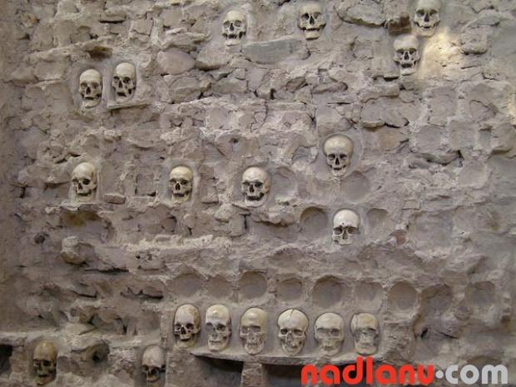

.

EXCURSIONS
WHOLE DAY TRIPS

VINEYARD OF VRŠAC
Vršac and its surroundings have been known as viticulture region since ancient times. This vineyard area covers a great part of the slopes and the bottoms of Vršac mountains where natural conditions enable successful vine growing. The viticulture of this region dates from the Roman rule of these areas and lasts until today. The assortment consists mostly of white wine varieties for the production of quality and top quality wines. Italian Riesling is the most represented variety (over 50%), followed by Rhein Riesling, White Burgundy, Chardonnay, Muscat Ottonel, Spice Traminer, Kreaca, Smederevka... The group of red wine varieties includes Frankovka and Muscat Hamburg varieties. The autochthonous and world-renowned variety Kreaca is definitely the pride of “Vineyards of Vršac”.

OPLENAC - TOPOLA
Orašsac is known as the place where Karadjordje signed an agreement to start the fight against the Turks, in history later called the First Serbian Uprising. Travel continues to Arandjelovac, a small town in the center of Šumadija located in the foothills of the mountains Bukulja and Venčac. In Topola you explore the city - hill Oplenac and St. George - the mausoleum of the royal family and the house Karadjordjevic Petar I, king and queen villas, vineyards kings and royal cellars at the foot of the hill that is in the center of Topola – Karadjordje’s town and church of the Holy Virgin built by the Great Serbian Leader.

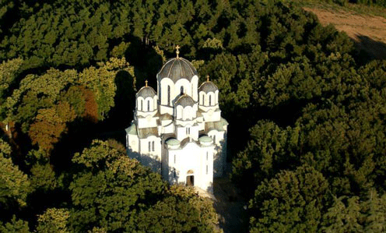

RESAVA CAVE
The Resava Cave lies in the eastern Serbia in the vicinity of the town of Despotovac (20 km). It is the first cave to be prepared for visits in Serbia. The length of the cave totals to 2,850 meters and the tourist paths is 800 m long. The Resava Cave consists of three floors of passages and halls connected by artificial tunnels. Only parts of the first and second floors (Upper and Lower Gallery) have been prepared for visits. An underground river flows through the lowest floor (Third Gallery).

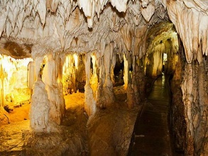

CASTLES OF VOJVODINA
Some of the families would get their estates as gifts from the royal court in Vienna, for their military merits, but also through inheritance or marriage. Best known for building castles in Vojvodina were the families of Dundjerski, Lukac and Stratimirovic.
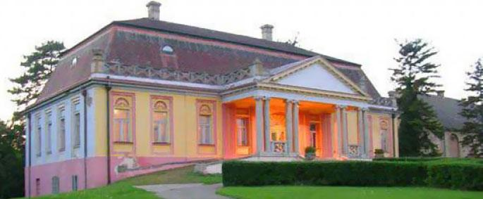
This tour includes visiting of three castles: Kulpin, Fantast and Sokolac and Carlsberg brewery and its Museum, dedicated to its founder Lazar Dundjerski. Curator will introduce you to the story of the first beer created from this factory, how suppliers transported the ingredients and how they stored the beer. You'll have the opportunity to see catering equipment that was used 100 years ago.

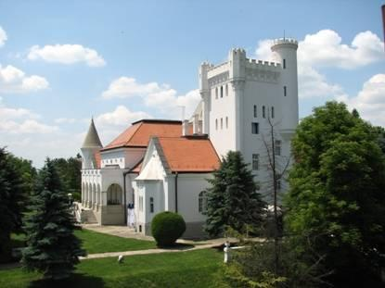

DEVIL’S TOWN
Devil's Town is a natural monument in southern Serbia, known to many as one of the 77 candidates for natural world wonders. When it entered the competition, two years ago, Devil’s Town was the most successful European candidate in its category (rock formations) and, even more importantly, it ran the race until the very final vote, which ended in the summer of 2010. This period also marked the beginning of activities aimed at the nomination of this site for the UNESCO World Heritage List.
Back in the past, people were unable to account for the origins of Devil's Town, so many legends were told on the subject. One of the legends says that the earthen figures are actually remnants of churches which were devastated by devils. Only recently has Devil's Town become a tourist attraction, the only European one that can compete with the much more celebrated Garden of the Gods in the USA.
Since 1959, Devil’s Town has been under state protection. In 1995, by a decree of the Serbian government, it was proclaimed a natural asset of outstanding significance. During the campaign for Seven Natural World Wonders, much work was completed on the site – a 9km-long artery, a car park and a viewpoint were built, the path was illuminated, water was supplied and a maintenance service was organized with accompanying facilities. The decorative illumination enables nightly tours of the site, which is visited by more than 50,000 guests annually.
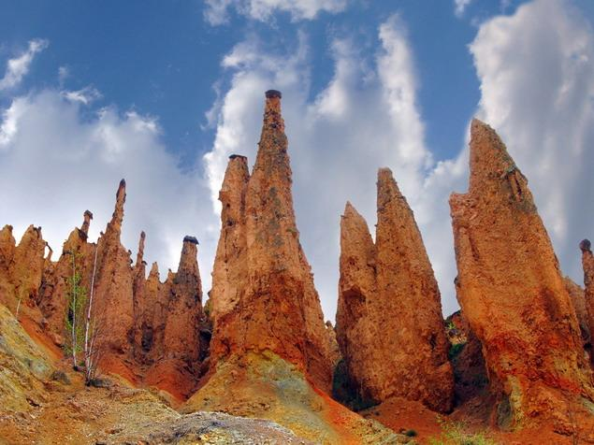
Tour of Devil’s Town can be arranged as a whole day excursion or with an overnight in Prolom spa.

VIMINACIUM
Viminacium, where the Mlava flows into the Danube, we find one of the most important Roman towns and military encampments from the period from the 1st to the 6th century. Viminacium was often chosen as a mustering point for troops and a starting point in many a military campaign. The exceptional finds made in the necropoles around the town confirm the belief that its citizens were very wealthy, and frescoes found in the crypts represent the peak of late classical period art.

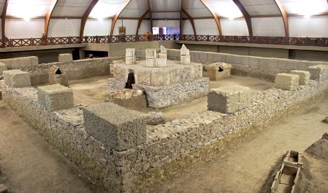

UVAC
Uvac river canyon is considered to be one of the most beautiful localities in Serbia. It is situated in the south-east of Serbia, between Javor and Zlatar mountains. It is known for its sandwiched meanders. It is one of the last habitats of the white-headed eagle, species all but extinct. The natural beauty of the Uvac River region is truly breathtaking. The Canyon offers something for any nature-lover which is why Uvac River Canyon is one of Serbia's top tourist destinations.

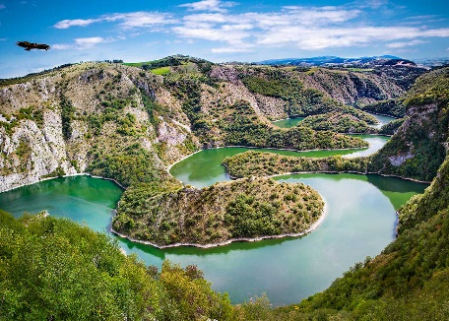

WINE ROUTES

Serbia is the capital of untouched nature, healthy food – fruits and vegetables, but also the cradle of wine, grape growing and winemaking. Each wine region has at least one wine route, which follows local roads to the place where wine can be tasted and bought. Such places are usually small farms surrounded by vineyards.

Just 8 km from Subotica is Palic, 8 km long, 950 meters wide and 2 meters deep lake. The lake’s healing waters have attracted visitors since the 19th century, when its first spa was built. Today, the lake is a well established modern resort featuring hotels, villas, sports facilities, 3 beaches and a beautiful zoo.
Basically, all of the 24,000 hectares of the Subotica-Horgos sands are suitable for grapevines. The region’s vineyards are concentrated around the town in the municipalities of Kanjiza and Subotica. The most common varieties are Chardonnay, Kevedinka, Italian and Rhine Riesling, Pinot Blanc, Merlot, Cabernet Sauvignon, Pinot Noir and Red Burgundy.

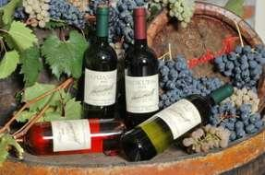

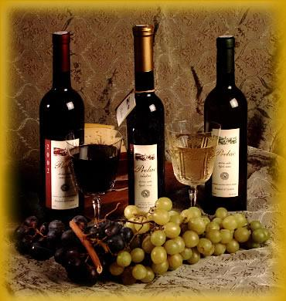

MONASTERIES

Fruška gora
Across an area 50 km long and 10 km wide, in the FruŠka Gora hills in the district of Srem, there are 16 Serbian Orthodox monasteries built in the late Middle Ages. Most of the monasteries were built under the influence of the Morava and Raška schools of architecture. The general area of Fruška Gora has been rich in religious sites since ancient times, and during the 16th and 17th centuries, 35 monasteries recorded here.

Ovčar and Kablar gorge
Within a narrow geographical region, in the Zapadna Morava river gorge, lies a large group of monasteries, named “Serbian Holy Mountain”. Most of the monasteries were built during the period of Turkish rule, when they had great historical, cultural and artistic value. The original number of monasteries is unknown, but today there are ten.

Monasteries of Raška district – Valley of the Kings
The journey through the Valley of the Kings begins at Kraljevo, one of the major cities of central Serbia. The Ziča monastery is considered the “mother of all churches”, with its characteristic red façade. It is the place where its benefactor, Stefan Prvovenčani (’the First-Crowned’) was crowned the first Serbian king of the Nemanjić dynasty. Legend tells that six more kings were crowned here and that for each a door were opened and then bricked up, hence the poetic name, Ziča of the Seven Doors. This tour also includes monasteries: Studenica, Djurdjevi Stupovi, Sopoćani and Gradac.

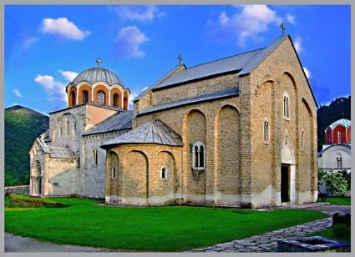

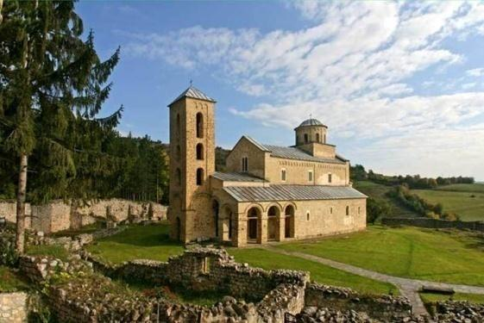

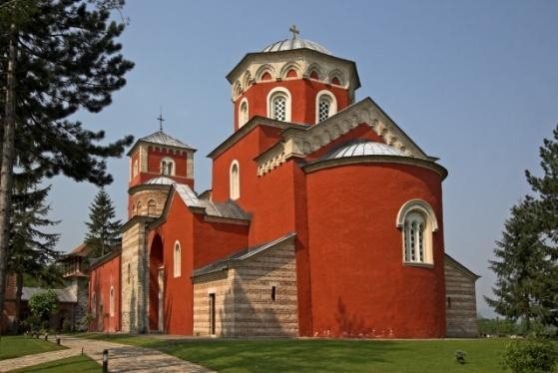

FARMSTEADS

Farmsteads (salasi) are found in all three districts of Vojvodina: Bačka, Banat and Srem. Some farmsteads are over 200 years old and are true ethnic museums. While the classic way of life of Vojvodina has been preserved on some farmsteads, many of them have been refurbished and adapted to meet the needs of modern life, with swimming pools, sports courts and fishing ponds amongst other recreational facilities. The larger farmsteads also have stables, mini zoos, ethnic museums and collections. They are not only ideal for a peaceful yet active holiday, but also for enjoying excellent cuisine and first class local wines and rakija to the cheerful sound of the tamburica.

